X Telecom

IP transport network Innovation Project

|  |  |
| --- | --- |
| **Contacts ：** | **XXX** |
| **Date ：** | **May 17, 2024** |

# Basic information

|  |  |  |
| --- | --- | --- |
| **Contact**  **information** | Author | Mr.xxxx, Ms.yyyy |
| Company | Network Planning & Design Dept, xx Telecom |
| Address | xxxxxxx |
| Type | 囗Carrier 囗Enterprise 囗Research Institution 囗University & College 囗Individual/others |
| **Project name** | IP transport network Innovation Project | |
| **Project track** | 囗Carrier 囗Enterprise | |
| **Contacts** | Mobile | xx-0531234567 |
| Email | xx@yy.com |

# Requirement and Solution

## Project Background

**//** **This section Introduce IP Project background and requirement**

**//Example:** current network is facing three major challenges : high-speed and full Wi-Fi coverage, more than 40000 terminals can access the network at the same time. The event management system requires high reliability and low latency (< 20 ms). The live HD video of the event is free of frame freezing.

## Detailed Solution

**//** **This section describes the networking architecture, functions, and application scenarios of the project in detail. you can put network topology diagram.**

**//Example:**

### High Density Stadium Wi-Fi Deployment

1. **Requirements**

**// This section describes project network requirements.**

**// Example:** The stadium requires 100% coverage to allow all spectators to access the Wi-Fi network. In addition, the number of concurrent users must account for 20% to 30% of the total number of Wi-Fi users. Onsite football fans can samless roam, and services must remain uninterrupted.

1. **Solution**

**// This section describes the networking architecture in detail. you can put network topology diagram.**

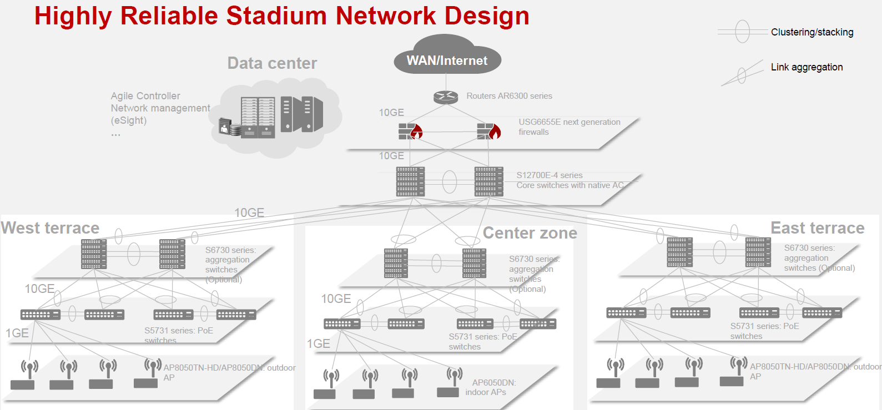

### IP bearer network based on slicing

1. Requirements
2. Solution

## Project Innovations Points

**//This section describes the innovation in detail.**

1. Innovation1：The first Wi-Fi 6 project in XXXX
2. Innovation2: The first SRv6 and slicing project in XXX

## Results (or expected Results)

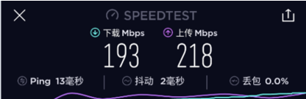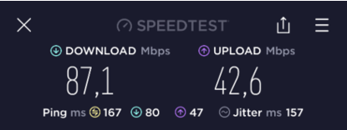**//This section describes the solution value, including test results, Third-party test reports, customer evaluation. For project under construction, please provide expected results**

## Economic value and Industrial values

**//This section describes the business value, ARPU, DOU, and penetration rate of this project are improved. You also can describe Values for the development of the local IP industry, Awards, Certificates, Publications, Papers…**